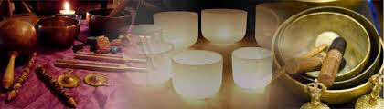

**Join us for at The Birch Studio for**

**Sunday Sound Bath’s**

**The combination of Crystal bowls, gong, tuning forks and voice creates a relaxing, energizing and blissful environment to relax, recharge and heal.**

**Sunday Dec 3, 10 & 17**

**Time: 1pm-3pm**

**cost: $40**

**Space is limited to 8**

**Book your spot here,**

**cindy@thebirchstudio.com**